**PHP Website Host on EC2**

**Step 1:- Launch an EC2 instance**

Choose AMI (ubuntu,amazon linux)

Select instance type based on needs.

Select key-pair

Select appropriate security group with ports 22,80

**Step 2:- Connect to your EC2 instance**

**Step 3 :- Install Apache web server**

Install apache2/httpd according to the AMI selected and start it.

Install Apache :-

***apt install apache2 -y (for ubuntu)***

***yum install httpd -y (for amazon linux)***

Start Apache service:-

***systemctl start apache2/httpd***

**Step 4:- Removing files generated**

After starting apache2/httpd, a file named index.html is generated.

This is the default path for apache server.

Command:**-**

***rm -rf /var/www/html/index.html***

**Step 5:- Install php and required extensions.**

Extensions required may vary according to the project demands.

Commands:-

***apt install php -y***

***yum install php -y***

**Step 6:- Getting website files**

Here I used git repo, you can use different methods.

Website source code and other files.

Make sure you have git installed.

In ubuntu AMI , git is already installed.

Command:-

***git clone ‘https://github.com/PratikBorge/php.git’***

**Step 7:- Moving website files to /var/www/html**

Moving all the files to /var/www/html as it is the default path of apache to host.

Command:-

***mv ./php/* /var/www/html***

**Step 8:- Restarting apache2 service**

Restarting apache2/httpd service

Commands:-

***systemctl restart apache2/httpd***

**Here is the jenkins pipeline with node.**

pipeline{

    agent{

        label 'agent3'

    }

    stages{

        stage("install apache"){

            steps{

                sh'''

                sudo apt install apache2 -y

                sudo systemctl start apache2

                '''

            }

        }

        stage("removing index.html"){

            steps{

                sh'''

                sudo rm -rf /var/www/html/index.html

                '''

            }

        }

        stage("install php and cloning from git"){

            steps{

                sh'''

                sudo apt install php -y

                sudo git clone 'https://github.com/PratikBorge/php.git'

                sudo mv ./php/* /var/www/html

                sudo systemctl restart apache2

                '''

            }

        }

    }

}

**Build Stages:-**

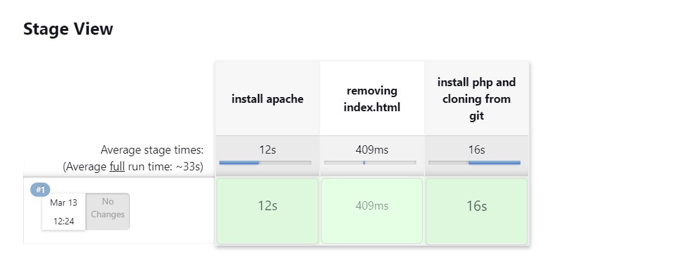

**Hosted website:-**

